Prototype 1 Report

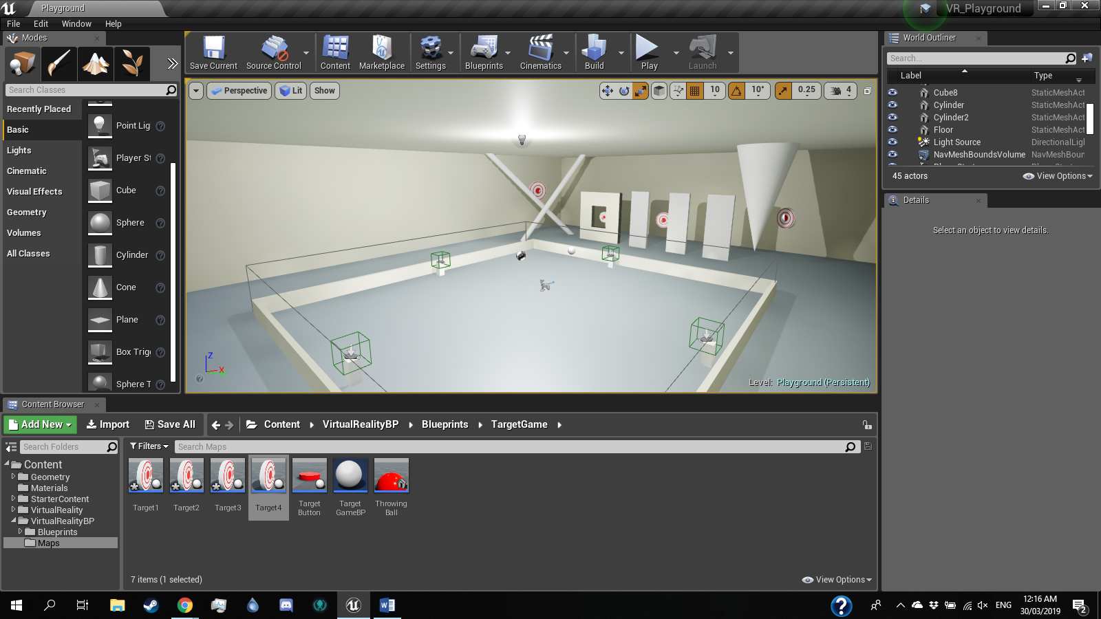At this stage, the level has been constructed. The functions of the players movement and interaction with the objects and the world has been created. The buttons and their functionality have been created, and can easily be applied to each minigame.

Level

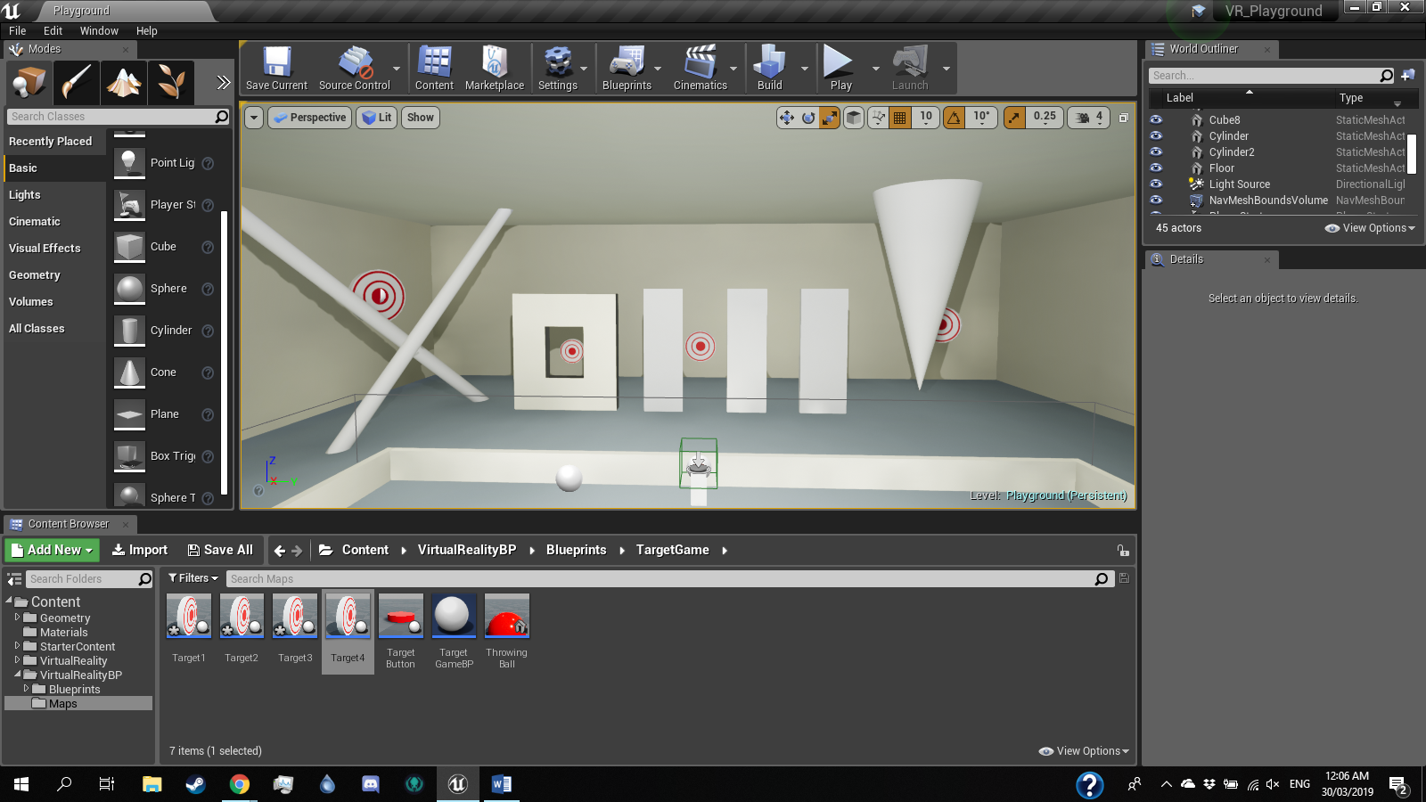The area for the target shot game has been completed.

Since the button is ready, I will create a blueprint that will start a timer and cause the targets to move, and also track number of targets hit. I will also create a spawner that will dispense balls that will be thrown at the targets, which can be done with a simple looping Spawn Actor blueprint.

After this, I will proceed with the other three minigames.